Mesopotamia Unit Test
Name __________________________________________ Date _________________
- Geography
- _______________________
- _______________________
- _______________________
- _______________________
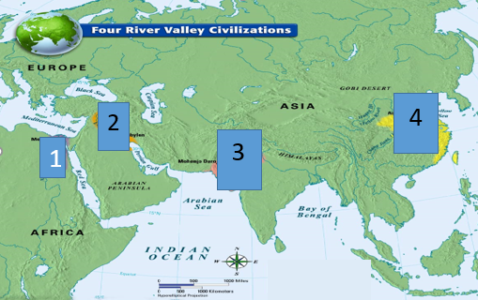
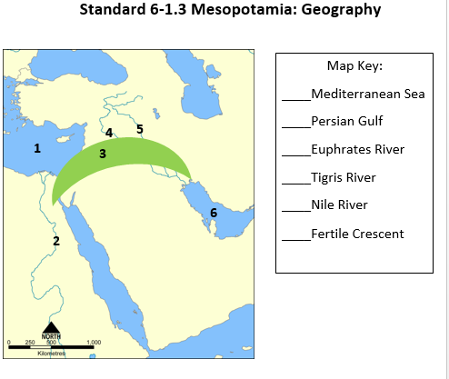

- Architecture
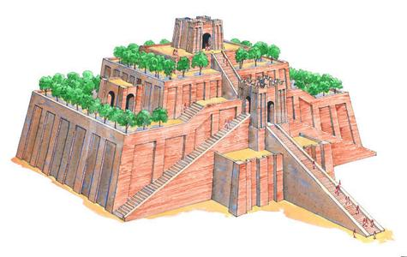
A. Mesopotamia was known for building ___________________.

B. These temples were built for their _____________________

C. Only _________________ could go inside.

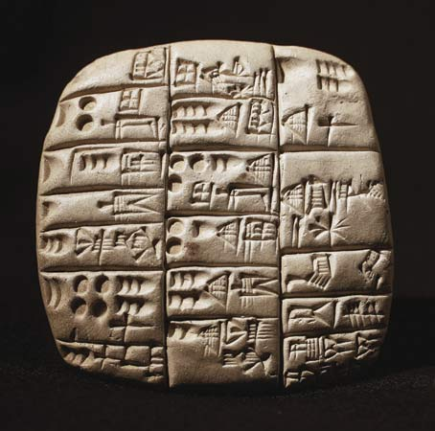
- Written Language
D. The people of Mesopotamia communicated by using ______________________, their
written language.

E. A __________________ was a professional writer.

F. They developed this writing to: _____________________________________________

_______________________________________________________________________

- Government

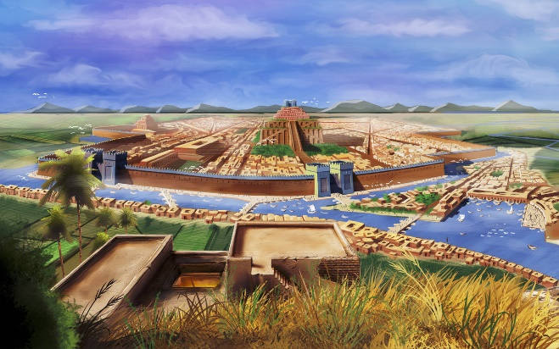
G. Mesopotamia was divided into _______________________________.

H. Each of these had their own:

___________________________

___________________________

I. Each of these were ruled by a ________________________ or __________________________
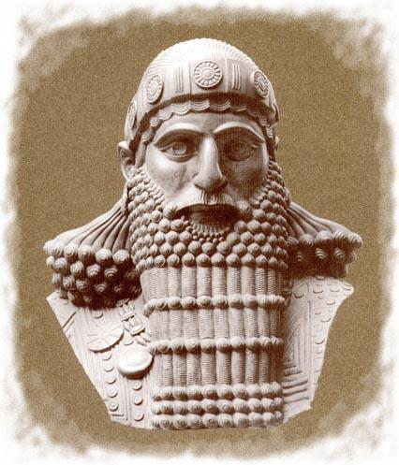
J. One of the most famous rulers was _________________________________.

K. He created the first ____________________________________________.

L. Give one example: ______________________________________________________________

______________________________________________________________________________

- Social Order: Complete the social order pyramid.
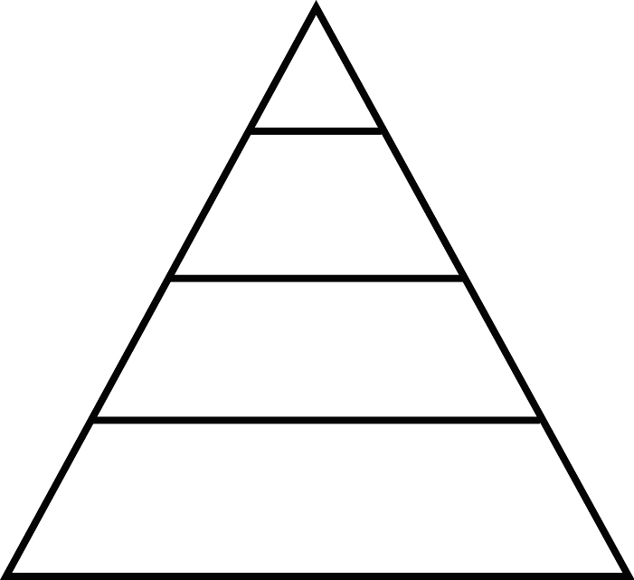
N.
M. What does ‘social order’ mean? n

_______________________________________________________________________________________________

_______________________________________________________________________________________________

__________________________________________________

__________________________________________________

- Trade Systems
O. Mesopotamia had to trade because ________________________________________________________________.
P. Examples of traded items: ___________________________ ________________________ ___________________
Q. What were some different ways they traded goods with others?
_____________________ _________________________ ___________________________
R. Identify the correct trade system used by the Mesopotamians:
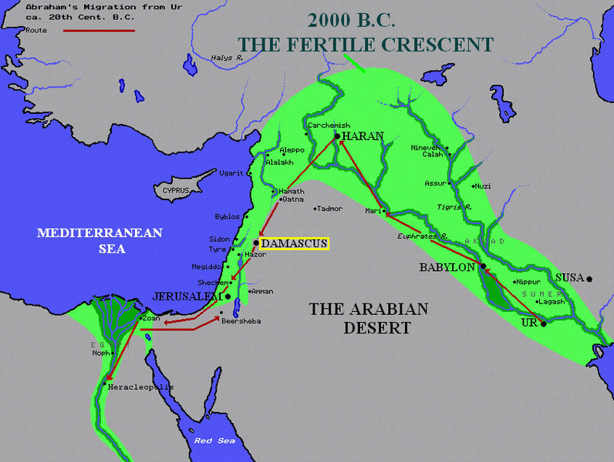
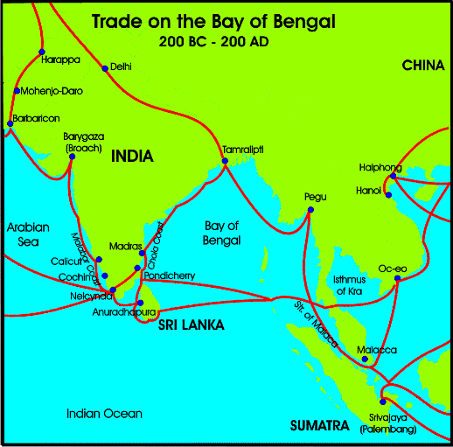
A. B.

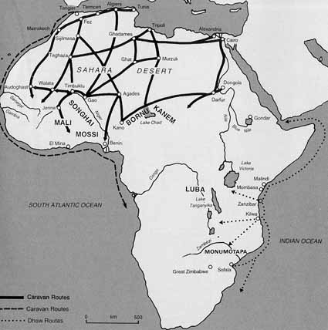
C.

S. How do you know? ________________________________________________________________________________
_________________________________________________________________________________________________
T. Complete the Quizizz:

